**Background:**

* 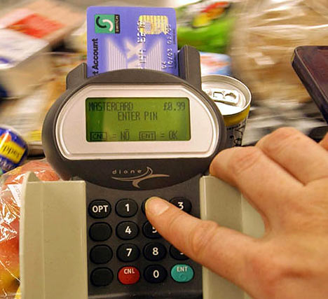PINs (Personal Identification Numbers) are used in a wide   
  range of security applications.
* Four digit PINs (e.g. 1234) are the most common as they are   
  convenient and provide some security. However, six digit PINs   
  (e.g. 123456) should be used whenever possible for improved   
  security.

**Assignment:**

1. Write a simple program that does the following:
   1. Asks the user to enter a 4 digit PIN. This will be the target PIN that the program   
      will try to “crack”.

pin = int(input("Enter a 4 digit pin"))

* 1. Runs a loop that starts at 1 and stops when the target PIN is found.

currentCount=1000

while (currentCount!=pin) :

currentCount = currentCount + 1

print("Count = %d" % currentCount)

print("pin has been cracked")

1. Enhance your basic program to include the following code:
   1. The purpose of this code is to measure how long it takes to “crack” the pin.
   2. On average, how long does it take to “crack” a PIN? Try several combinations.

After trying multiple pins in the enhanced program, I find that the average time it takes is around 0.4 to 0.6 seconds.

import time

startTime = time.time()

loopCount = 1

while (loopCount <= 1000) :

loopCount = loopCount + 1

endTime = time.time()

print("Elapsed time is:", (endTime - startTime) )

Enhanced program:

pin = int(input("Enter a 4 digit pin"))

import time

startTime = time.time()

currentCount=1000

while (currentCount!=pin) :

currentCount = currentCount + 1

print("Count = %d" % currentCount)

print("pin has been cracked")

endTime = time.time()

print("Elapsed time is:", (endTime - startTime) )

1. Many people use insecure PINs that contain repeated digits such as “1111” or simple sequences such as “1234”.
   1. Enhance your program to try some different digit repeats or digit sequences in order to crack the PIN faster.
   2. Include your enhancements before the main loop.

Enhanced program:

import time

pin = int(input("Enter a 4 digit pin"))

startTime = time.time()

if (pin==1111 or pin==2222 or pin==3333 or pin==4444 or pin==5555 or pin==6666 or pin==7777 or pin==8888 or pin==9999 or pin==1234 or pin==4321) :

print("Pin is not secure")

else:

currentCount=1000

while (currentCount!=pin) :

currentCount = currentCount + 1

print("%d" % currentCount)

print("pin has been cracked")

endTime = time.time()

print("The time it took to crack the pin is:", (endTime - startTime))

* 1. How does this affect the time needed to “crack” a PIN?

1. Research some other ways that people choose insecure PINs. (e.g. birthday dates)
   1. Enhance your program to check for some of these insecure patterns.

import time

pin = int(input("Enter a 4 digit pin"))

startTime = time.time()

if (pin==1111 or pin==2222 or pin==3333 or pin==4444 or pin==5555 or pin==6666 or pin==7777 or pin==8888 or pin==9999 or pin==1234 or pin==4321 or pin==1000 or pin==2000 or pin==3000 or pin==4000 or pin==5000 or pin==6000 or pin==7000 or pin==8000 or pin==9000 or pin==2004 or pin==2003 or pin==2002 or pin==2001 or pin==2000) :

print("Pin is not secure")

else:

currentCount=1000

while (currentCount!=pin) :

currentCount = currentCount + 1

print("%d" % currentCount)

print("Pin has been cracked")

endTime = time.time()

print("The time it took to crack the pin is:", (endTime - startTime))

1. Explain how the use of a six digit pin would increase security. Refer to some of the things you discovered while writing the programs for this assignment.

6 digit pins would be much harder to crack and increase the security. Due to the pin being 6 digits, if a hacker would be using the brute force method, it would take much longer to crack compared to a 4 digit pins.